**Practical File of C**

**(BCA 103)**

**BACHELOR OF COMPUTER APPLICATIONS**

**Academic Session: - 2021-22 Batch-2021-24**



**Submitted To: - Submitted By: -**

**Name- MRS. AMBOOJ YADAV Name: - Upanshu Choudhary**

**Programme: -BCA**

**Semester: -1**

**Shift: - EVENING**

**Division: - B**



**INDEX**

|  |  |  |
| --- | --- | --- |
| **S.NO** | **TOPIC** | **SIGNATURE** |
|  | **Write a program to print “Hello” ?** |  |
|  | **Write a program to find the sum of two Elements?** |  |
|  | **Write a program to find the percentage of five Variables?** |  |
|  | **Write a program to find the ascii value of a character?** |  |
|  | **Write a program to swap two numbers?** |  |
|  | **Write a program to Swap two numbers using a third variable?** |  |
|  | **Write a program to display different Variables?** |  |
|  | **Write a program to find Perimeter and radius of a circle?** |  |
|  | **WRITE A PROGRAM TO CALCULATE SUBTRACTION, MULTIPLICATION, ADDITION AND DIVISION.?** |  |
|  | **Write a program to check the greatest number of three numbers?** |  |
|  | **Write a program to find eligibility of being a voter using if condition?** |  |
|  | **Write a program to find odd and even number?** |  |
|  | **Write a program to check that number is greater than 100 and less than 1000?** |  |
|  | **Write a program to print your resume?** |  |
|  | **Write a program to make a calculator using switch?** |  |
|  | **Write a program to find odd and even using goto method?** |  |
|  | **Write a program to find the simple interest ?** |  |
|  | **Write a program to change celsius to farenhite ?** |  |
|  | **Write a program to check number is Armstrong or not?** |  |
|  | **Write a Program to find increment and decrement of a given number?** |  |
|  | **Write a program to display range of fundamental Datatypes?** |  |
|  | **Write a program to demonstrate the size of operators?** |  |
|  | **Write a program to find Square of number whose significant digit is 5?** |  |
|  | **Write a program to calculate salary of a medical representative based on the sales.** |  |
|  | **Write a program to find simple interest and compound interest?** |  |
|  | **Write a program to print first five number with their square?** |  |
|  | **Write a program to print series of number and find their sum input taken by user?** |  |
|  | **Write a program to find perfect square from 1 to 500?** |  |
|  | **Write a program to find factorial of a given number?** |  |
|  | **Write a program to print reverse series of number 100 to 1?** |  |
|  | **Write a program to print Fibonacci series for a given term?** |  |
|  | **Write a program to reverse digits of a number?** |  |
|  | **Write a program to print a series of number using do while loop?** |  |
|  | **Write a program to print series and their square using do while loop?** |  |
|  | **Write a program to take data of 5 students and count the students whose age is less than 25 and weight less than 50 kgs?** |  |
|  | **Write a program to find number is palindrome or not?** |  |
|  | **Write a program to print good morning, afternoon ,evening message using function?** |  |
|  | **Write a program to show function without argument and return value example?** |  |
|  | **Write a program to show function without argument and with return value example?** |  |
|  | **Write a program to show function with argument and without return value example?** |  |
|  | **Write a program to show function with argument and with return value example?** |  |
|  | **Write a program to print numbers and their sum upto five using recursion?** |  |
|  | **Write a program to find sum of digits of a number using recursion?** |  |
|  | **Write a program to check whether number is prime or not using function?** |  |
|  | **Write a program to swap two numbers using call by value in function?** |  |
|  | **Write a program to swap two numbers using call by reference in function?** |  |
|  | **Write a program to print a number ladder pattern?** |  |
|  | **Write a program to print alphabetical ladder pattern?** |  |
|  | **Write a program to print Diamond pattern?** |  |
|  | **Write a program to find remainder and quotient of a given dividend and divisor?** |  |
|  | **Write a program to find largest number among three number using logical**  **And operator?** |  |
|  | **Write a program to print an array elements and their address side by side?** |  |
|  | **Write a program to print array elements and their address take array length input from user?** |  |
|  | **Write a program to find given year is leap year or not using array?** |  |
|  | **Write a program to find the sum of odd and even numbers from an array take array length and elements input from user?** |  |
|  | **Write a program to check the occurrences of a character in a string ?** |  |
|  | **Write a program to find min and max number from an array?** |  |
|  | **Write a program to print an array row and column wise?** |  |
|  | **Write a program to add two matrices using two-dimensional array?** |  |
|  | **Write a program to find transpose of a matrix using two-dimensional array?** |  |
|  | **Write a program to print address of elements of an array using pointer?** |  |
|  | **Write a program to print value of an array by index and by using pointer to pointer?** |  |
|  | **Write a program to store n elements in an array and print the elements using pointer?** |  |
|  | **Write a program in C to find the largest element using Dynamic Memory Allocation?** |  |
|  | **Write a program to calculate the length of the string using pointer?** |  |
|  | **Write a program to print a string reverse using pointer?** |  |
|  | **Write a program to input elements in an array using dynamic memory allocation (use calloc)?** |  |
|  | **Write a program to read an array and print the sum of all elements using dynamic memory allocation (use malloc)?** |  |
|  | **Write a program to increase size of allocated memory of a string using realloc?** |  |
|  | **Write a program to print sum of two numbers using extern function?** |  |

Q.1-Write a program to print “hello” in the program?

Input:

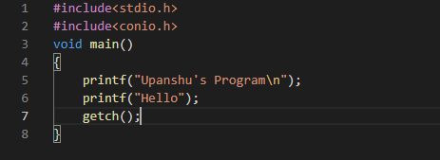

output:



Q.2Write a program to write the resume in the program?

Input:

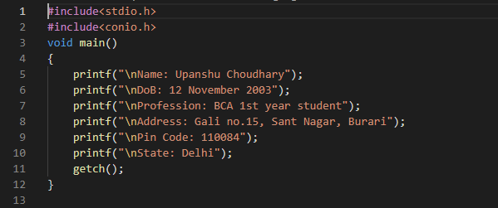

Output:

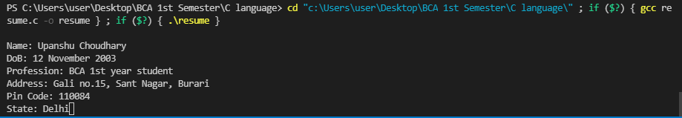

Q.3 Write a program find the sum of 2 numbers?

Input:

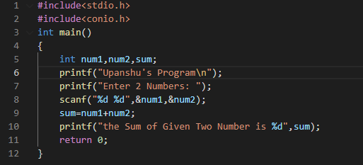

Output:

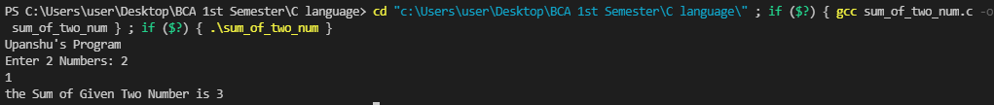

Q.4 Write a program to find ASCII code of a character?

Input:

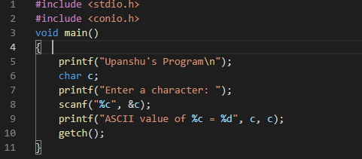

Output:



Q5. Write a program to print char type variable.

Input:

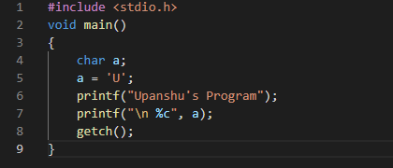

Output:



Q.6 Write a program to increase and decrease the value taken from the user?

Input:

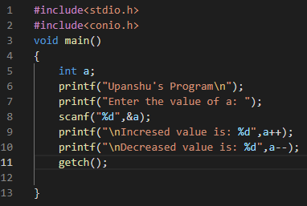

Output:

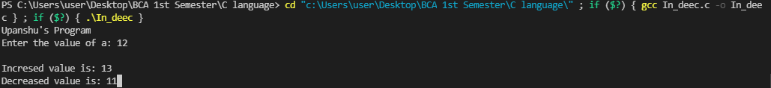

Q.7 Write a program to find the output of the given 2 numbers from the user by using arithmetic operators?

Input:

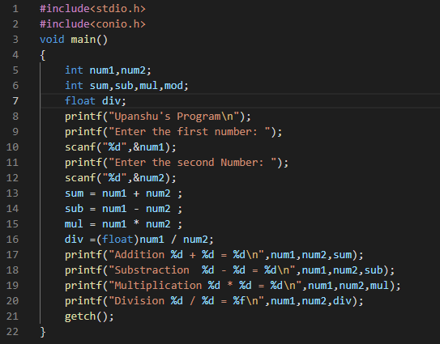

Output:

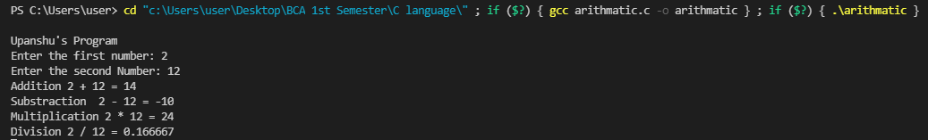

Q.8 Write a program find the area and perimeter of a circle?

Input:

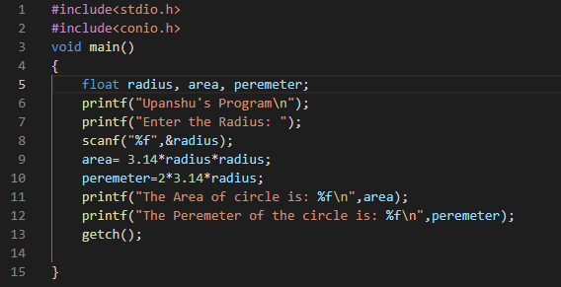

Output:

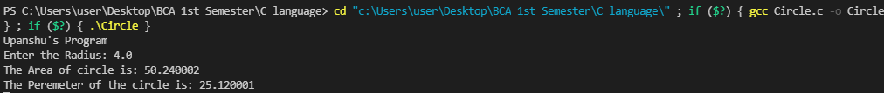

Q.9 Write a program to find the quotient and remainder from the given values.

Input:

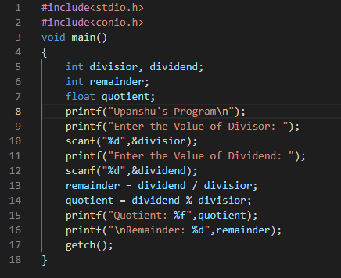

Output: 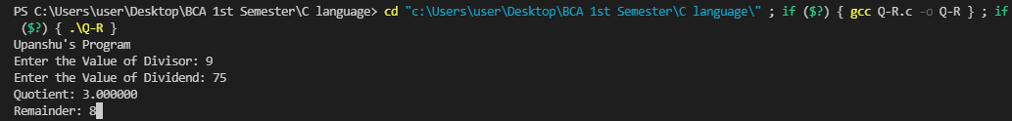

Q.10 Write a program to check whether the human age is eligible for voting or not.

Input:

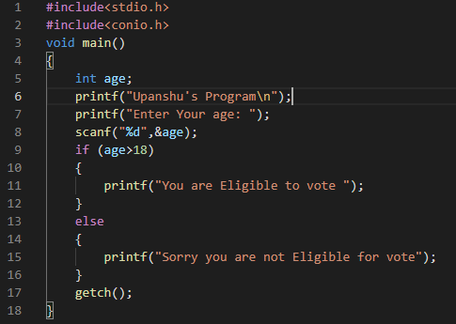

Output:



Q.11 Write a program to find positive and negative value from the user

Input:

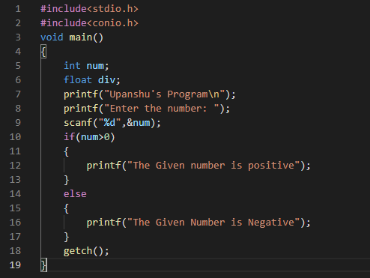

Output:



Q.12 write a program to find out odd and even numbers?

Input:

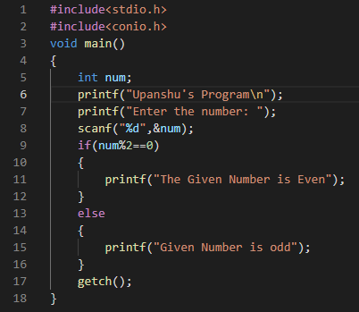

Output

Q.13 Write a program to check whether the number is greater than 100 and less than 1000?

Input:

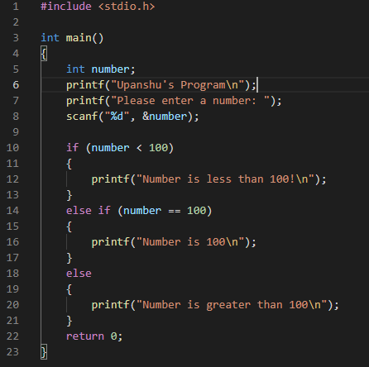

Output:



Q.14 Write a program to find greatest or maximum of three numbers using ternary method

Input: 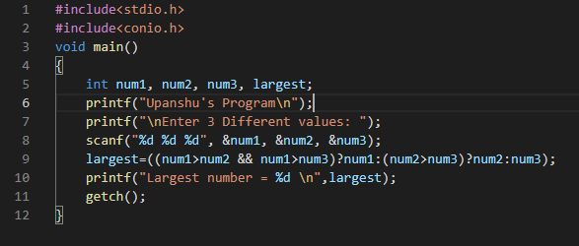

Output:

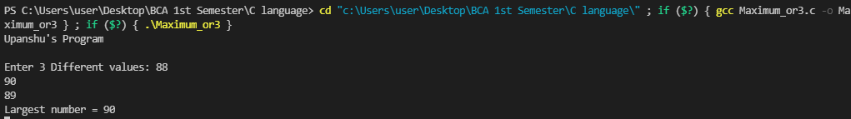

Q.15 Write a program to Swap 2 Numbers

Input:

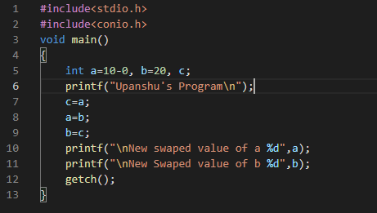

Output:

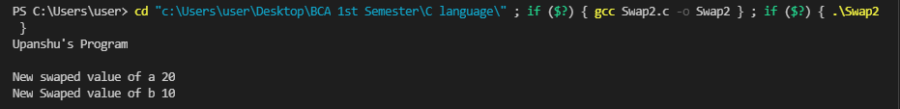

Q.16 Write a program to swap 2 values without third variable.

Input:

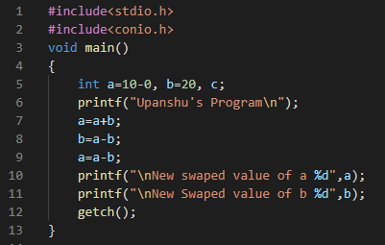

Output:

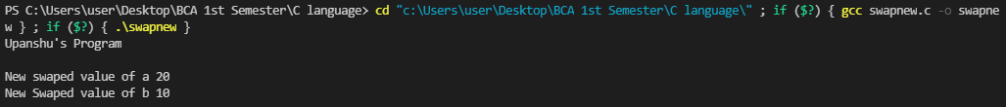

Q17. Write a program to print datatypes and strings.

Input:

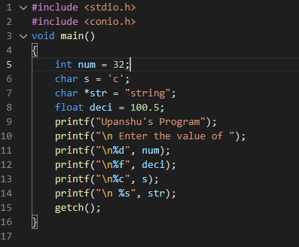

Output:

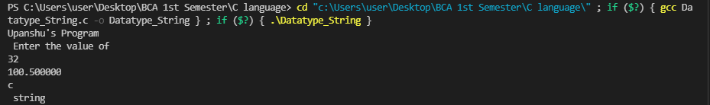

Q18. Write a program to print sum and percentage of five subjects.

Input:

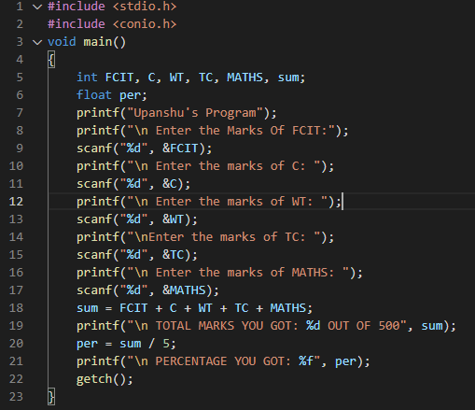

Output:

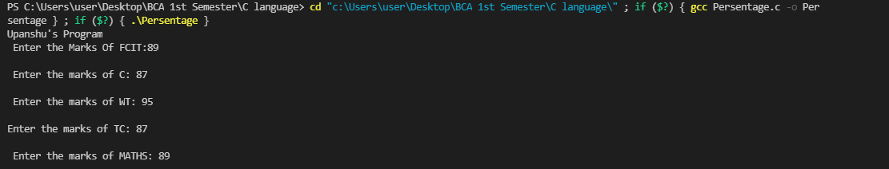

Q19. Write a program to create a calculator of arithmetic functions using switch case.

Input:

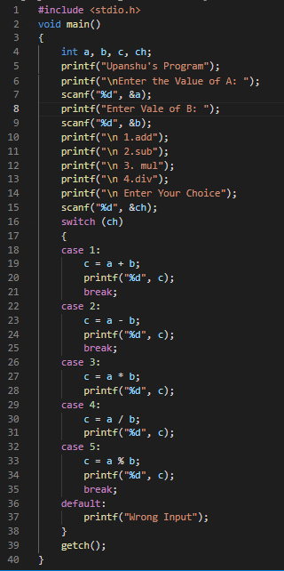

Output:

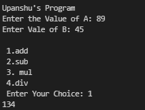

Q20. Write a program check no. is greater than 100 less than 1000.

Input:

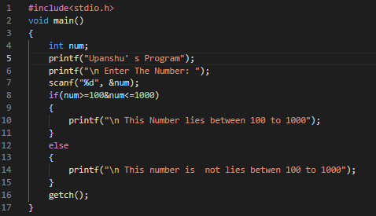

Output:



Q21. Write a program to demonstrate size of operators.

Input:

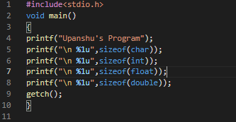

Output:



Q22. Write a program to print number is odd or even by using goto.

Input:

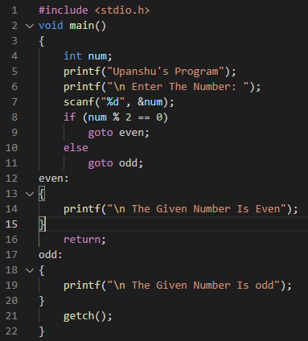

Output:

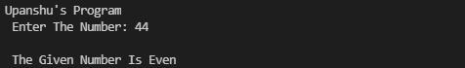

Q23. Write a program to check that number is prime or not.

Input:

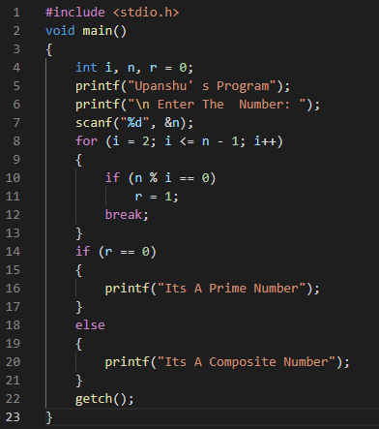

Output:



**Programme24: Write a program to find the simple interest?**

**Input:**

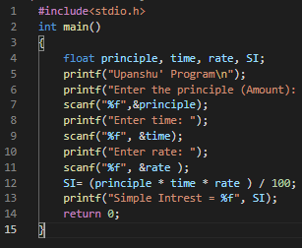

**Output:**

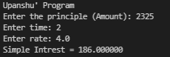

**Programme25: Write a program to change Celsius main to Fahrenheit?**

**Input:**

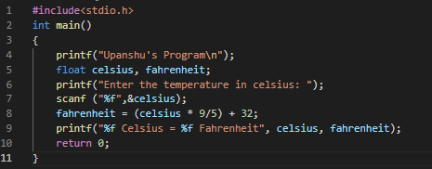

**Output:**



**Programme26: Write a program to check number is Armstrong or not?**

**Input:**

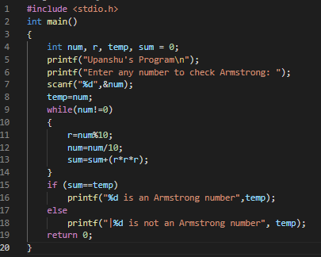

**Output:**



**Programme27: Write a Program to find increment and decrement of a given number?**

**Input:**

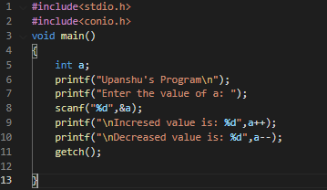

Output:

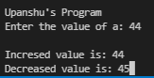

**Q28. Write a program to find Square of number whose significant digit is 5?**

Input:

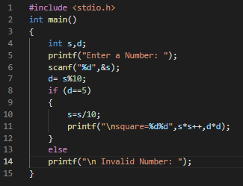

Output:

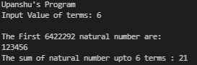

Q29. **Write a program to calculate salary of a medical representative based on the sales.**

**Bonus and incentives to be offered to him will be based on total sales if the sales exceeds or equal to Rs. 1,00,000 follow the particulars of table 1 otherwise follow table 2.**

**Table 1**

**Basic=Rs.3,000, HRa=20% of basic, Da=110% of basic, conveyance=Rs.500, incentive=10% of sales, bonus=Rs.500**

**Table 2**

**Basic=Rs.3,000, HRa=20% of basic, Da=110% of basic, conveyance=Rs.500, incentive=5% of sales, bonus=Rs.200**

**Input:**

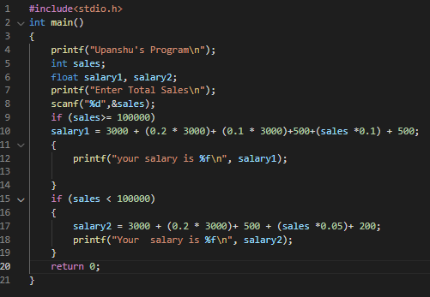

Output:



**Programme30: Write a program to print first five number with their square?**

**Input:**

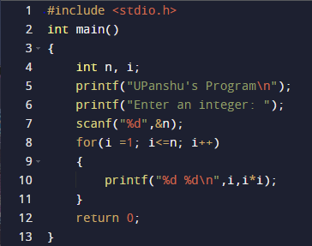

**Output:**

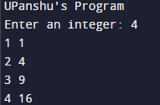

**Programme31: Write a program to print reverse series of number 100 to 1?**

**Input:**

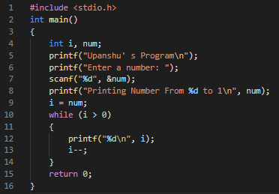

**Output:**

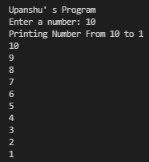

**Programme32: Write a program to print Fibonacci series for a given term?**

**Input:**

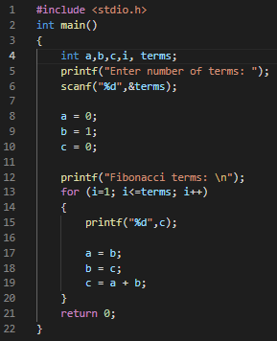

**Output:**

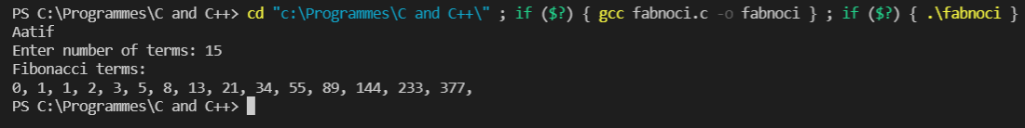

**Programme33: Write a program to reverse digits of a number?**

**Input:**

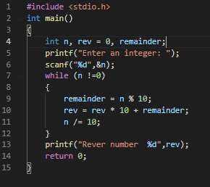

Output:

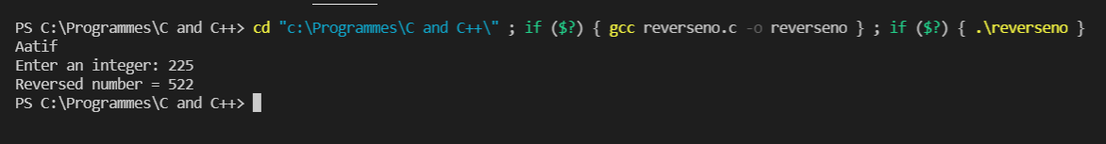

**Programme34: Write a program to print a series of number using do while loop?**

**Input:**

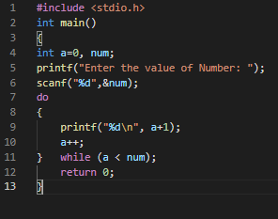

**Output:**

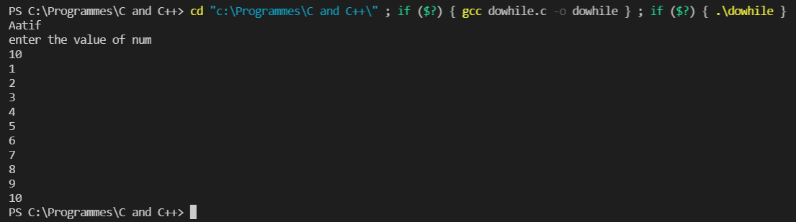

**Programme35: Write a program to print series and their square using do while loop?**

Input:

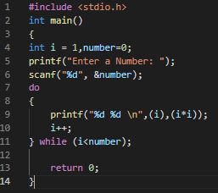

Output:

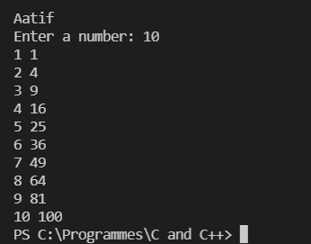

**Programme36: Write a program to take data of 5 students and count the students whose age is less than 25 and weight less than 50 kgs?**

Input:

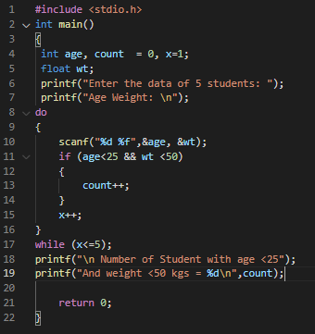

Output:

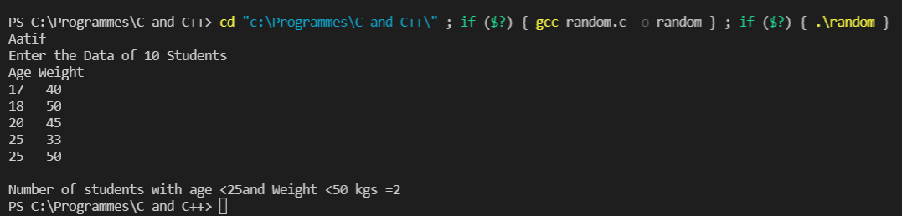

**Programme37: Write a program to print numbers and their sum upto five using recursion?**

**Input:**

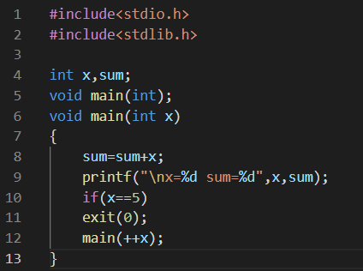

**Output:**



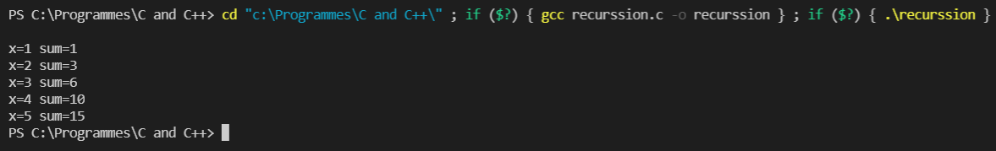

**Program38. write a program to print numbers and their sum upto five using recursion?**

**Input:**

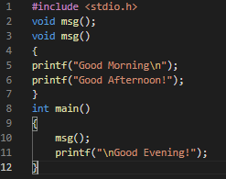

**Output:**

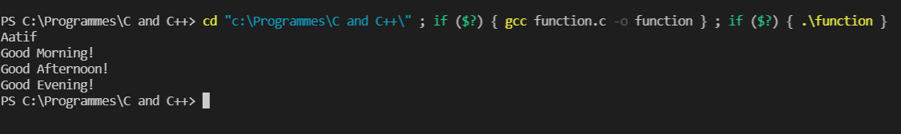

Question 39:

write a program to convert temp from Celsius to fathering by taking input from user

Input:

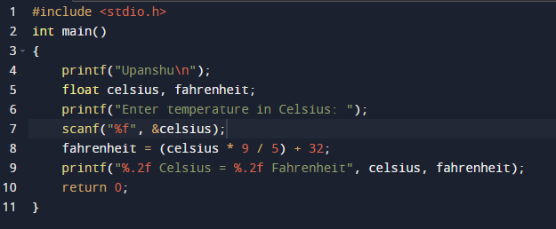

Output:

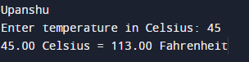

Question 40:

Write a program to find the greatest number among 3 numbers given by the user

Input:

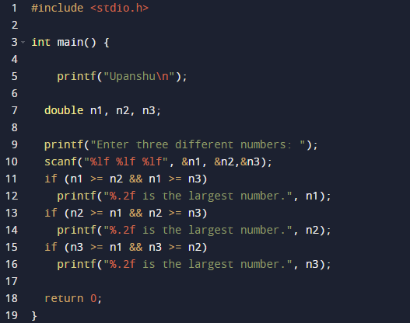

Output:

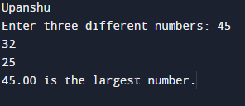

Question 41:

Write a program to check if a given number is a prime number or not.

Input:

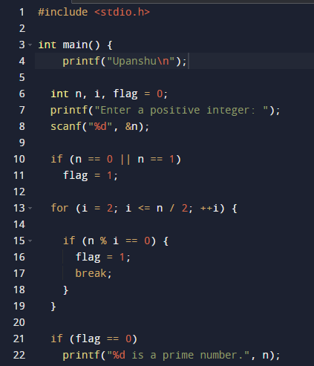

Output:

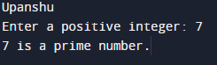

Question 42:

Write a program to display the following pattern up to N rows, taking the value of N from the user.

Input:

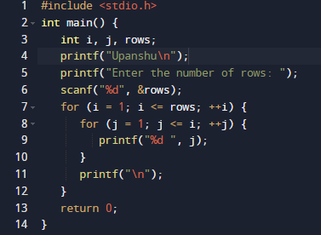

Output:

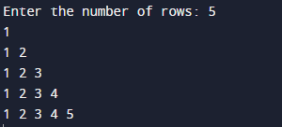

Question 43:

Write a program to input marks of 5 students using an array and display the average marks of the class.

Input:

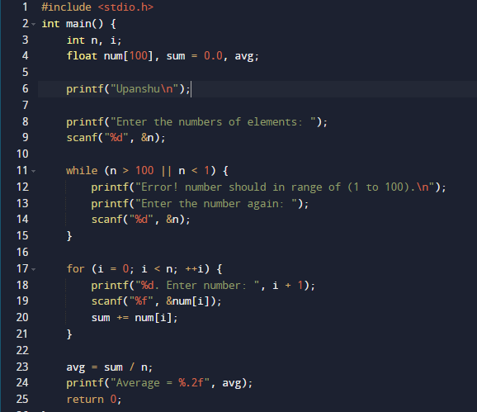

Output:

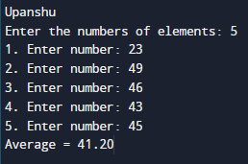

Question 44:

Write a program to search for a number entered by the user in a given array and display the array in ascending order.

Output:

Question 45:

Write a program to check if a string is palindrome or not.

Input:

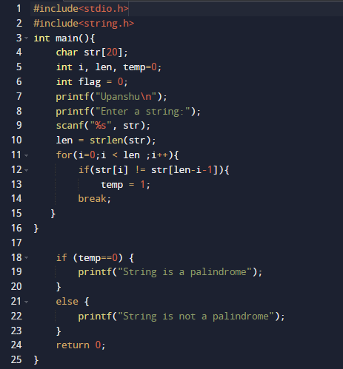

Output:

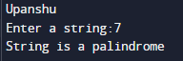

Question 46:

Write a program to add, subtract, multiply and divide two numbers using pointers.

Input:

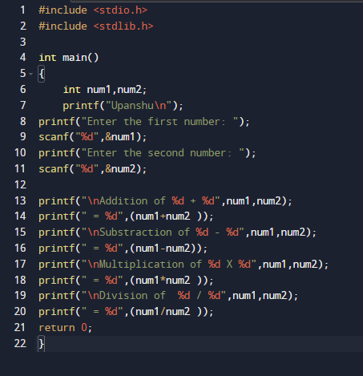

Output:

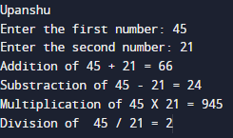

Question 47:

Write a program to create a structure for employees containing the following data members: Employee Name, Age, Address, Department and Salary.

Input data for 10 employees and display of the employee from the employee ID given be the user.

Input:

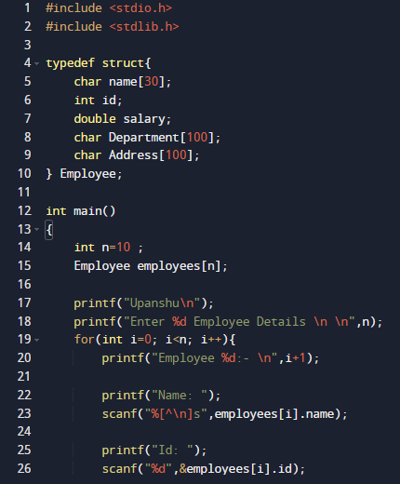

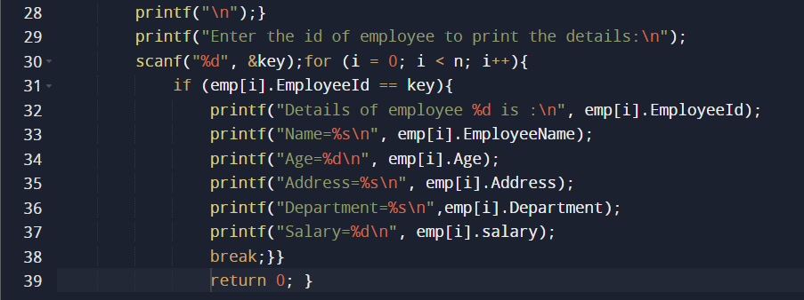

Output:

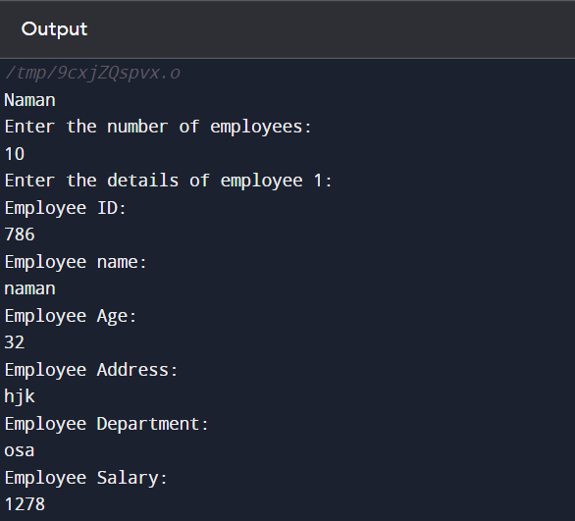

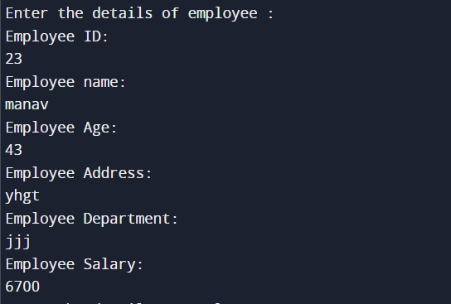

Question 48:

Write a program to create two files with names Even File and Odd File. Input 20 numbers from the user and save even numbers in Even File and odd numbers in Odd File.

Input:

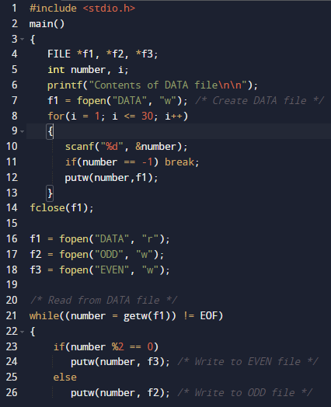

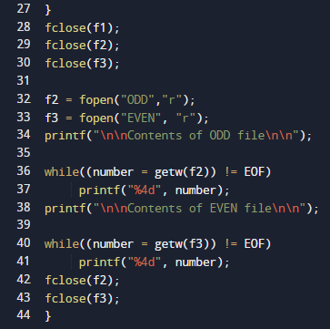

Output:

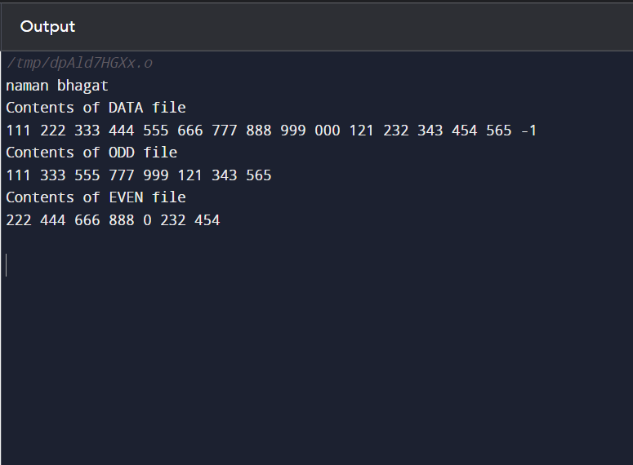

Question 49:

Write a menu driven program to construct a calculator for following arithmetic operations: addition, subtraction, multiplication, division, average and percentage.

Input:

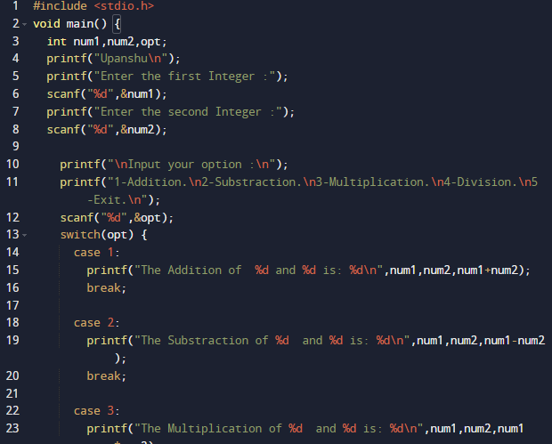

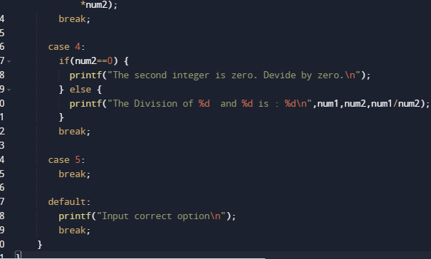

Output:

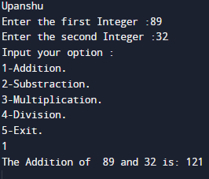

Question 50:

Write a menu driven program to perform the following operations:

1.Print Armstrong number up to N

2.Display prime number between 1 to N

3.Reverse of an integer

(i)

Input:

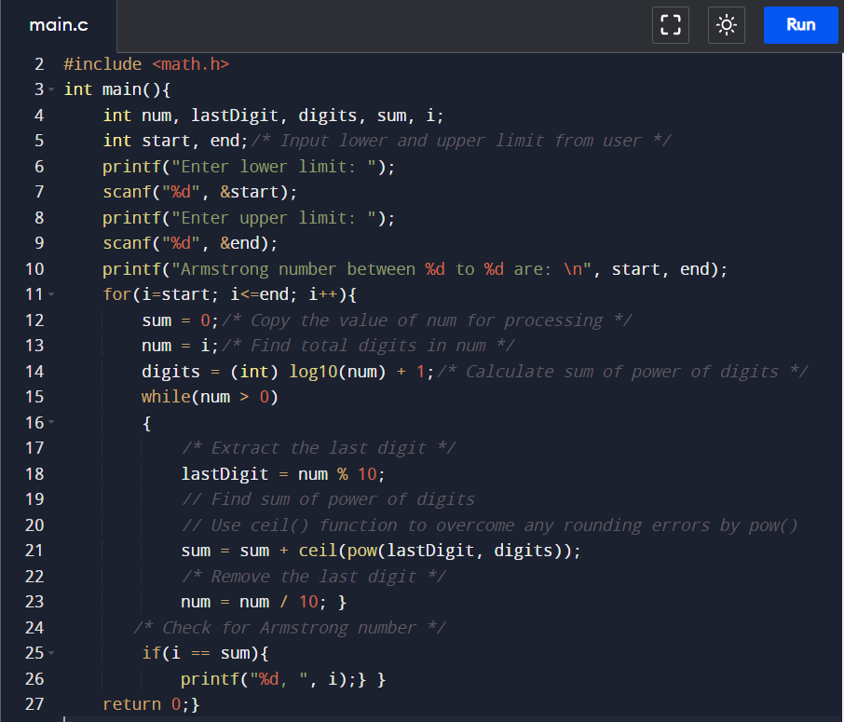

(ii)

Output:

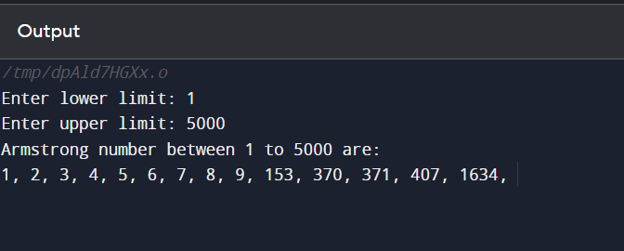

(ii)

Input:

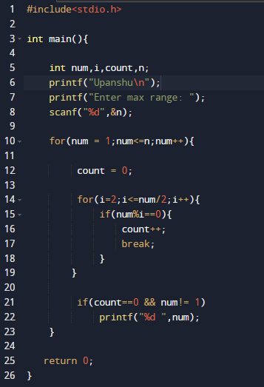

Output:

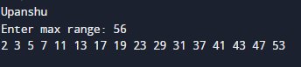

(iii)

Input:

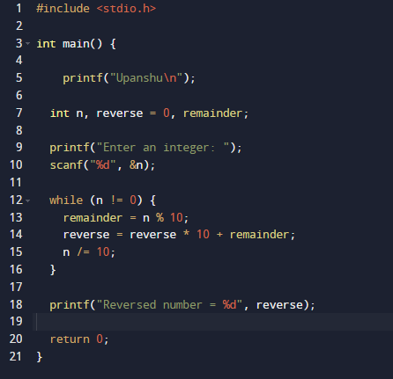

(iii)

Output:

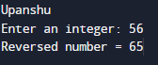

Question 51:

Write a program to convert a hexadecimal number into a binary number.

Input:

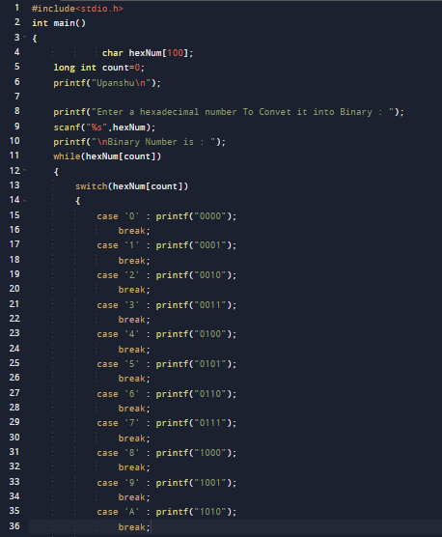

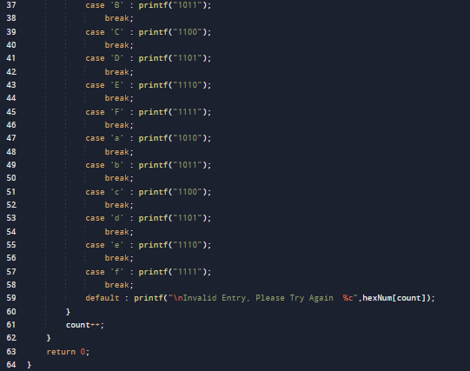

Input:

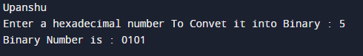

Question 52:

Write a program to calculate factorial of a number and display Fibonacci series up to N terms using recursive functions.

Input:

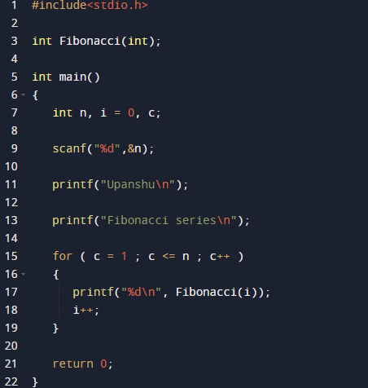

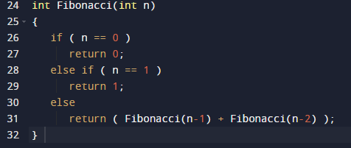

Output:

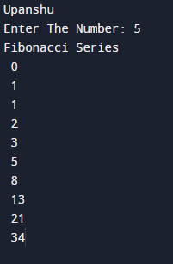

Question 53:

Write a program to perform matrix addition, multiplication, transpose on 2D arrays.

Input:

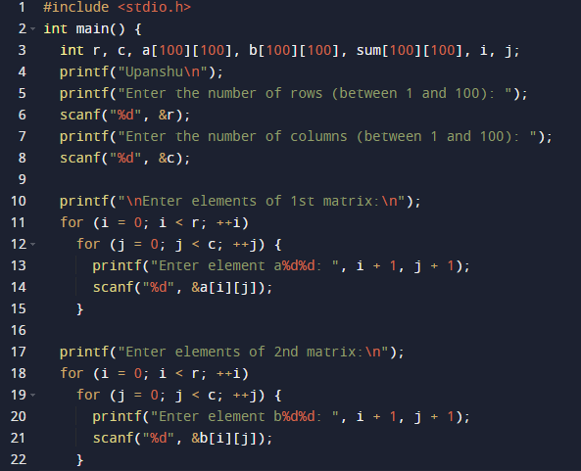

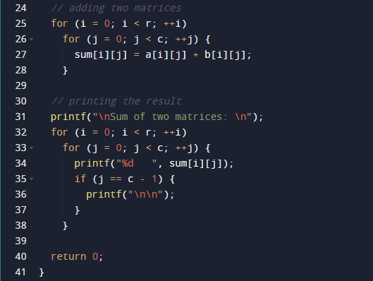

Output:

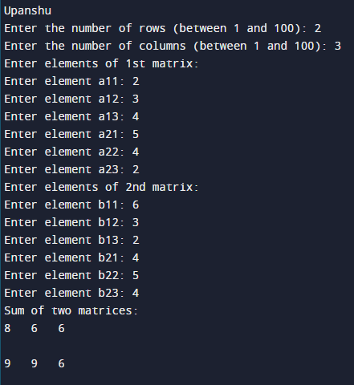

Question 54:

Write a program to make use of arrays with structures in the following ways:

1.Use array as a structure data member

2.Create array of structure variables

Input:

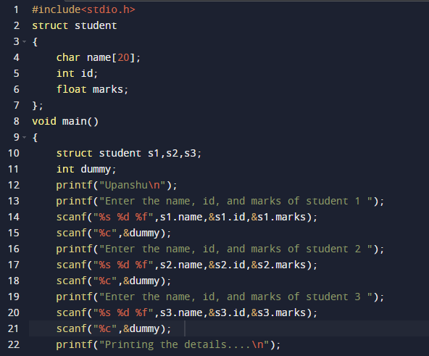

Output:

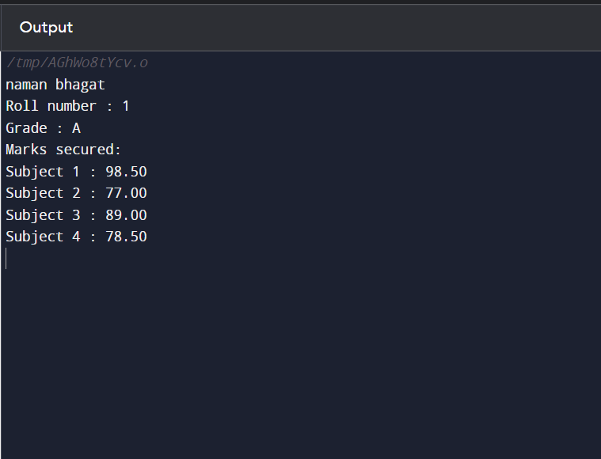

(ii)

Input:

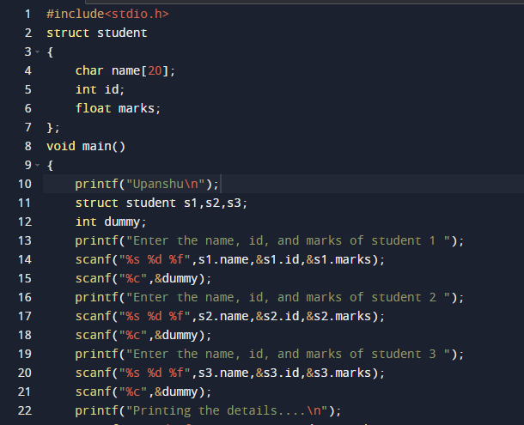

Output:

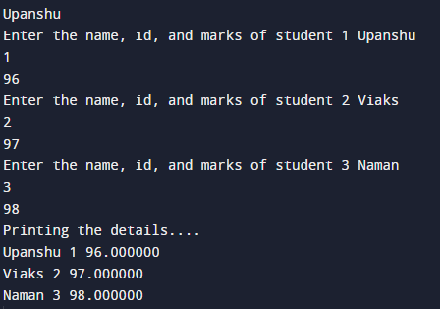

Question 55:

Write a program to compare the contents of two files by taking names of the files through command line arguments.

Input:

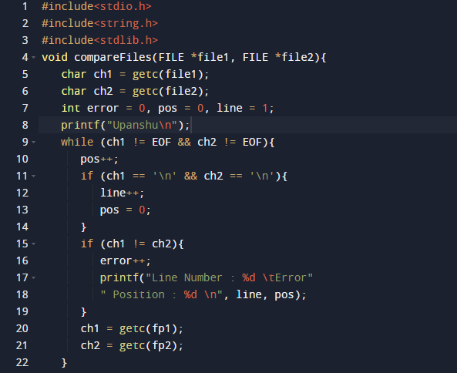

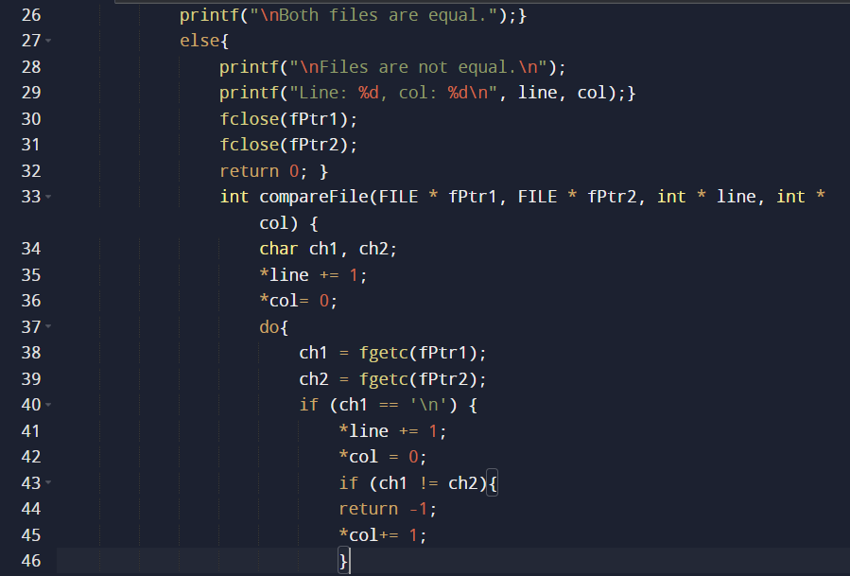

Output:

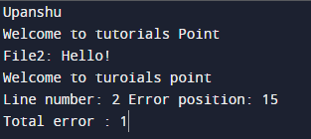

Question 56:

Write a program to perform input and make use of file positioning functions on binary files. (Using fseek, ftell, rewind functions).

Input:

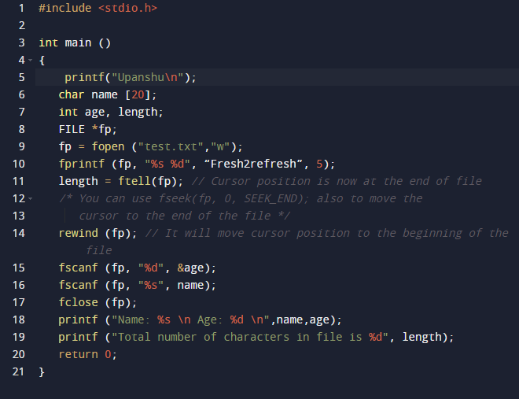

Output:

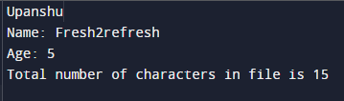

Question 57:

Write a menu driven program to implement the following string operations:

1.Calculate length of a string

2.Concatenate at the end of a given

3.Copy one string to another

4.Compare contents of two strings

5.Copy nth character string to another

(i)

Input:

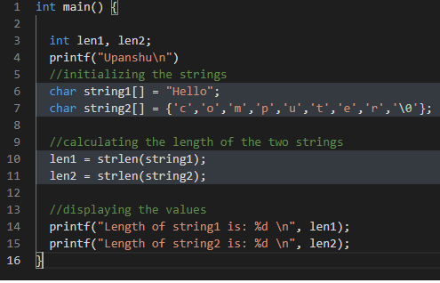

Output:

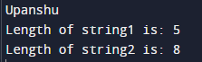

(ii)

Input:

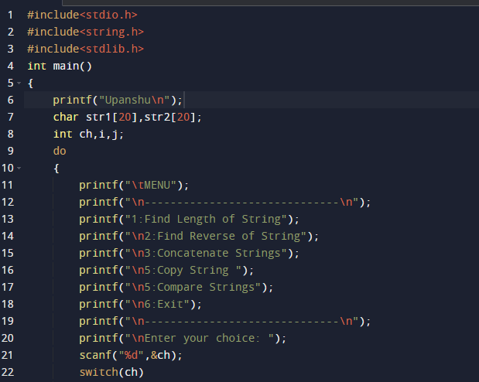

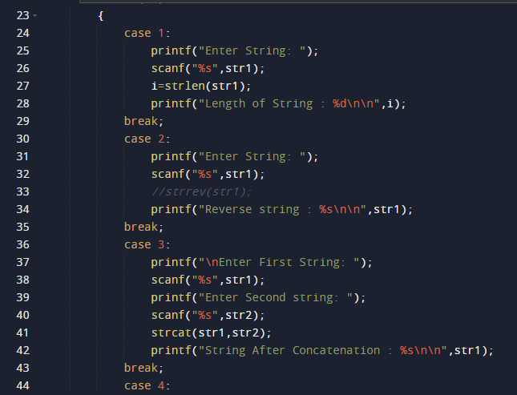

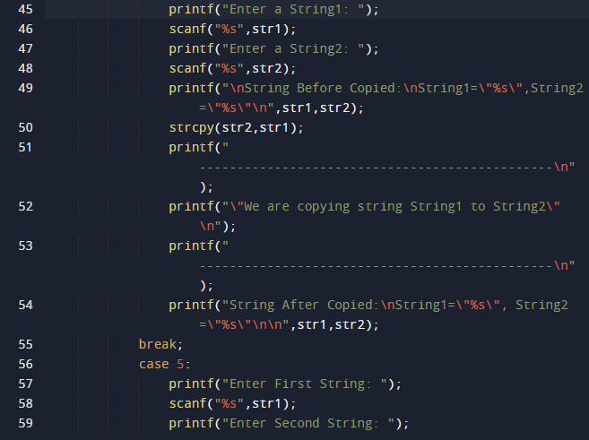

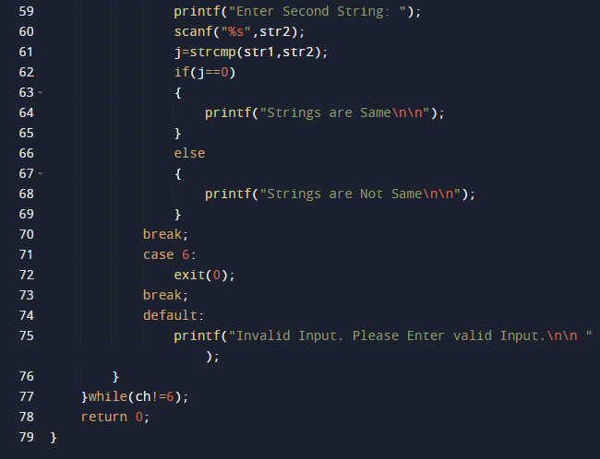

Output:

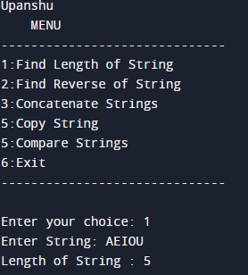

Question 58:

Write a program to read time in string format and extract hours, minutes and second also check time validity.

Input:

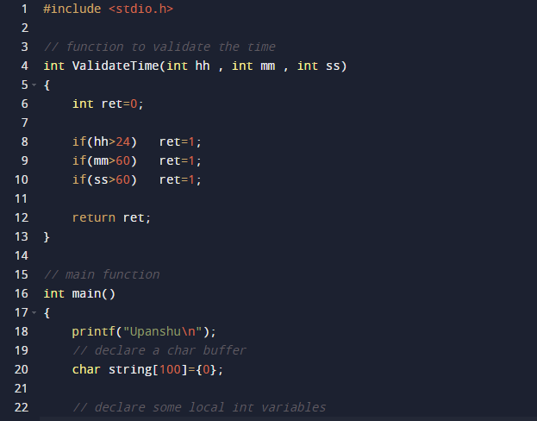

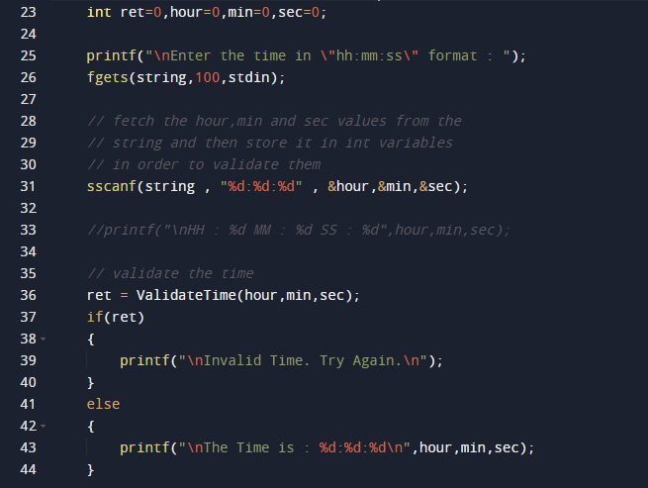

Output:

